Pages 29 – 39 and Page 79 in ***Java Programming A Comprehensive Introduction***

**Section 1: Define**

Variable limitations- The rules we follow to create a variables is called variable limitation. For instance, we can’t start a variable name with integer/ certain brackets etc.

control statements- Control flow statements the statements inside our source files are generally executed from top to bottom, in the order that they appear.

If (*condition*) statement- It is first line start with if, followed by the condition you want to test for. These goes between two round braces.

What is the **if / else** ladder / Describe how if else works- If/else is use for two different condition, one has to be true and other has to be false.

Boolean Expressions- It is expressions that are very similar to mathematical expressions, but instead of using mathematical operators such as “+” or “-“, you use comparative or Boolean operators such as “==” or “!”.

Relational Operators-

**(Define Each Symbol)**

**<** Less than

**<=** Less than and equal to

**>** Grater than

**>=** Grater than and equal to

**==**  Equal to

**!=** Not equal to

How do relational operators relate to **if** statements?-- In If statements we use rational operators for the conditions/ to compare two different values.

What does java.util.Scanner and **new** Scanner (System.in); allow the programmer to do?

Import statement- We use the import statement to call the library that are already stored in the program as a code form by somebody. So, while we import something we don’t need to write extra piece of program to do the same task, which save time.

Constructor- It is a block of code similar to a method that’s called when an instance of an object is created. Here are the key differences between a constructor and method: A constructor doesn’t have a return type. The name of constructor must be the same as the name of the class.

**Programming Assignments**

Task 1 –

Page 39. **in *Programming A Comprehensive Introduction***

**Update your program from Assignment 2, Task #2**

Allow the user to input their weight for the earth weight to moon weight conversion problem. Add an **if** statement that prompts the user if she inputs 0 or a negative number for her earth weight.

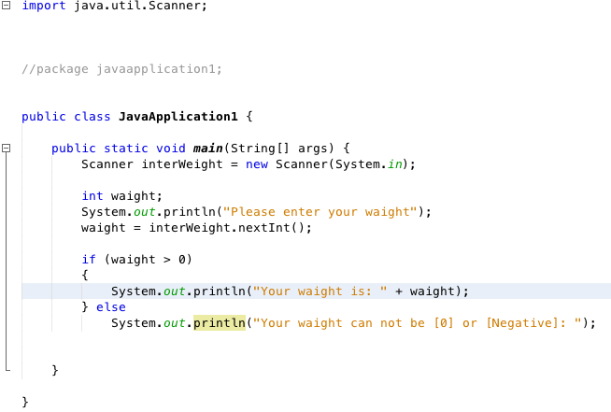

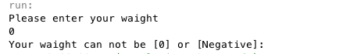

**#13.** Mars’ gravity is about 17 percent less that of the earth’s. (Meaning you weigh less on the moon). Write a program that computes your affective weight on Mars.

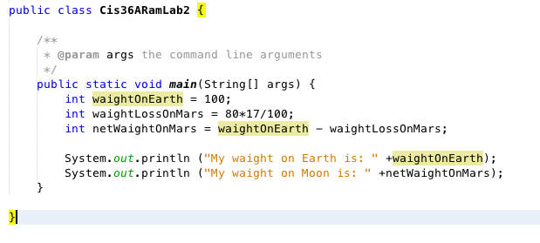

Macintosh HD:Users:ramyadav:Desktop:Screen Shot 2016-02-04 at 11.30.21 AM.png

P9. 29 in book

**2nd Task:**  Write a simple program displaying knowledge of **if** conditional statements and using the Scanner input method.

Create 2 input integer (**int)** variables. The input numbers should not be set by the programmer but entered by the user.

Have 2 simple equations that solve for a the variable ( **c ).** c = a – b and c = b – a

Create statements for if **(c)** is a negative or non-negative number for each equation.

Display the possible outputs for in each equation.

Please enter an integer: //Prompt the user

7 // Integer entered by the user not by the programmer.

Please enter an integer: //Prompt the user

9 // Integer entered by the user not by the programmer.

a = 7 // display the value of a

b = 9 // display the value of b

a is less than b // display the difference the relationship between and b

// Create space between each output

c = a – b

c = -2

c is negative //create a statement stating whether c is negative or positive.

c = b - a

c = 2

c is non-negative

